**PIZZA SALES SQL QUERIES**

* **Total Revenue :-**

SELECT SUM(Total_price) AS Total_Revenue FROM pizza_sales;

Output

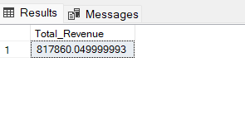

* **Average Order Values :-**

SELECT (SUM(Total_price) / COUNT(DISTINCT Order_id)) AS Avg_order_value

FROM pizza_sales;

Output

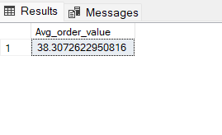

* **Total Pizzas Sold :-**

SELECT SUM(Quantity) AS Total_pizza_sold FROM pizza_sales;

Output

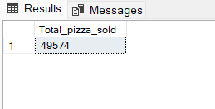

* **Total Orders :-**

SELECT COUNT(DISTINCT Order_id) AS Total_orders FROM pizza_sales;

Output

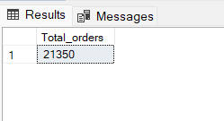

* **Average Pizzas per Order :-**

SELECT CAST(CAST(SUM(Quantity)AS DECIMAL(10,2)) /

CAST(COUNT(DISTINCT Order_id)AS DECIMAL(10,2))AS DECIMAL(10,2))

AS Avg_Pizzas_per_order FROM pizza_sales ;

Output

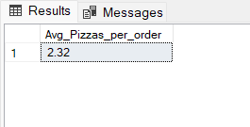

* **Daily Trend for Total Orders :-**

SELECT DATENAME(DW,Order_date) AS Order_Day, COUNT(DISTINCT Order_id) AS

Total_orders

FROM pizza_sales

GROUP BY DATENAME(DW,Order_date);

Output

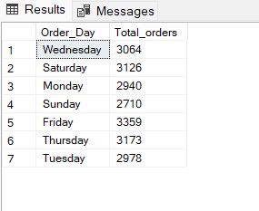

* **Monthly Trend for Orders :-**

SELECT DATENAME(MONTH,Order_date) AS Order_Month, COUNT(DISTINCT Order_id) AS

Total_orders

FROM pizza_sales

GROUP BY DATENAME(MONTH, Order_date);

Output

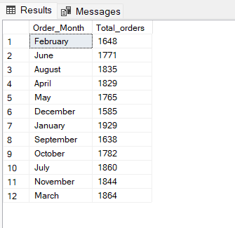

* **% of Sales by Pizza Category :-**

SELECT Pizza_category , CAST(SUM(Total_price)AS DECIMAL(10,2)) AS

Total_Revenue,

CAST(SUM(Total_price) * 100/ (SELECT SUM(Total_price) FROM pizza_sales)

AS DECIMAL (10,2)) AS PCT

FROM pizza_sales GROUP BY Pizza_category;

Output

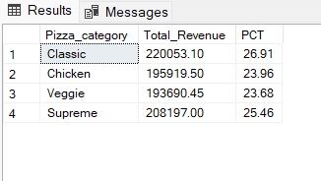

* **% of Sales by Pizza Size:-**

SELECT Pizza_size, CAST(SUM(Total_price)AS DECIMAL(10,2)) AS

Total_Revenue,

CAST(SUM(Total_price) * 100/ (SELECT SUM (Total_price) FROM pizza_sales)

AS DECIMAL (10,2)) AS PCT

FROM pizza_sales

GROUP BY Pizza_size ORDER BY Pizza_size;

Output

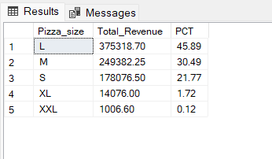

* **Total Pizzas Sold by Pizza Category :-**

SELECT Pizza_category, SUM(Quantity)AS Total_Quantity_Sold

FROM pizza_sales

WHERE MONTH(Order_date) = 2

GROUP BY Pizza_category

ORDER BY Total_Quantity_Sold DESC;

Output

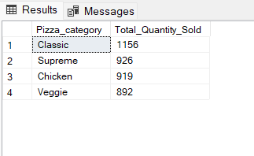

* **Top 5 pizzas by Revenue:-**

SELECT TOP 5 Pizza_name, SUM(Total_price)AS Total_Revenue

FROM pizza_sales

GROUP BY Pizza_name

ORDER BY Total_Revenue DESC;

Output

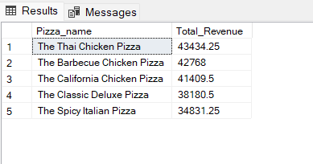

* **Bottom 5 Pizzas by Revenue:-**

SELECT Top 5 pizza_name, SUM(Total_price)AS Total_Revenue

FROM pizza_sales

GROUP BY Pizza_name

ORDER BY Total_Revenue ASC;

Output

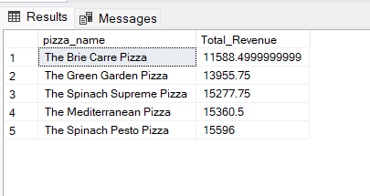

* **Top 5 pizzas by Quantity:-**

SELECT Top 5 pizza_name, SUM(Quantity)AS Total_pizza_sold

FROM pizza_sales

GROUP BY Pizza_name

ORDER BY Total_pizza_sold DESC;

Output

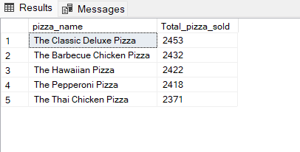

* **Bottom 5 Pizzas by Quantity:-**

SELECT Top 5 pizza_name, SUM(Quantity)AS Total_pizza_sold

FROM pizza_sales

GROUP BY Pizza_name

ORDER BY Total_pizza_sold ASC;

Output

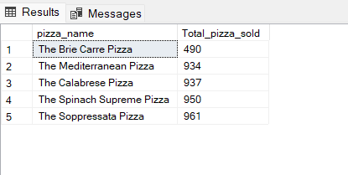

* **Top 5 pizzas by Total Orders:-**

SELECT Top 5 pizza_name, COUNT(DISTINCT Order_id)AS Total_Orders

FROM pizza_sales

GROUP BY Pizza_name

ORDER BY Total_Orders DESC;

Output

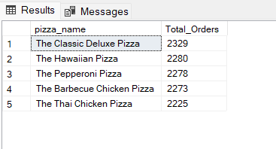

* **Bottom 5 Pizzas by Total Orders:-**

SELECT Top 5 pizza_name, COUNT(DISTINCT Order_id) AS Total_Orders

FROM pizza_sales

GROUP BY Pizza_name

ORDER BY Total_Orders ASC;

Output

